The Deca Tree
In the forest there is a Deca tree.
A Deca tree has 10 trunks, and on each trunk there are 10 branches,
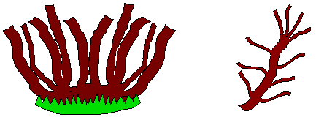
and on each branch there are 10 twigs, and on each twig there are 10 leaves.

One day a woodcutter came along and cut down one trunk from the tree.
Then he cut off one branch from another trunk of the tree.
Then he cut off one twig from another branch and finally he pulled one leaf from another twig.
How many leaves were left on the tree then?

