Plates of biscuits

There are 12 plates with 3 identical biscuits on each plate.
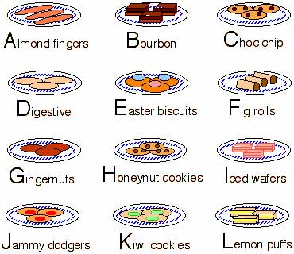
(These are named simply to help identify them by a letter!)
Can you rearrange the biscuits on the plates so that
1. the 3 biscuits on each plate are all different and
2. there is no plate with two biscuits the same as two biscuits on another plate?
For example, if you have one plate of "A, D and F" then you cannot have another with both "A and D" or "A and F" or "D and F".

