Hundred Square Puzzle
A hundred square has been printed on both sides of a piece of paper.
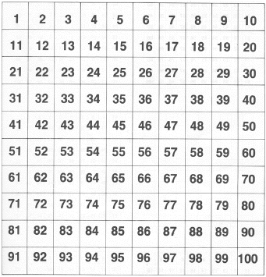
One square is directly behind the other.
What is on the back of 100? 58? 23? 19?
Can you see a pattern?
What if the hundred square on the back was printed upside down?

