Find a Path on the Christmas Tree

Can you find a path from the star at the top of this network on the Christmas tree to the bottom which goes through each of the 8 different shapes once and once only?
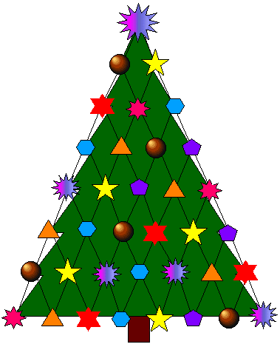
There is only one way to do it!

