Cross Numbers

Can you arrange the digits 1 to 9 in the cross below so that the two numbers in each of the blue-edged rectangles add to the number in the central red-edged box?
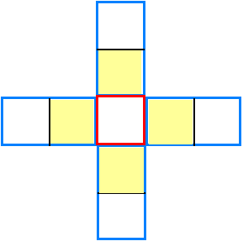
Now can you rearrange these numbers so that those in the 4 yellow squares add to twice the central number?
What do the 4 numbers in the outer squares add to?

