Choosing pizzas

Mum and Dad went to get pizzas with Daniel and Alice.
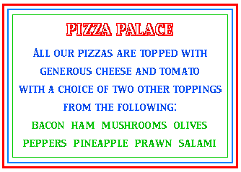
They read the notice and started to choose.
"I'll have salami and olives, I think," said Mum.
"Mushroom and bacon for me!" called out Alice.
"Prawn and pepper sounds nice," added Dad.
"Mine is pineapple and ham!" shouted Daniel.
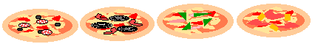
"If you mix up the toppings you get many more choices," said Alice, "just think ... olives and mushrooms ...... pineapple and prawn ..... bacon and ....."
"I'm losing count!" wailed Daniel.
How many variations of two toppings were there besides the ones they chose?

