A bowl of fruit

Here is a bowl of fruit.
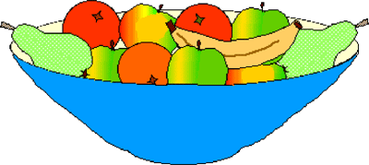
Half of the pieces of fruit in the bowl are apples. There are also 3 oranges, 2 pears and a banana.
How many apples are there in the bowl?
If, instead, one quarter were apples and one quarter were oranges and there were 4 bananas, 3 pears and 3 plums how many apples would there be?

