A Puzzling Cube

Here are the 6 faces of a cube - in no particular order.

Here are 3 views of the cube.
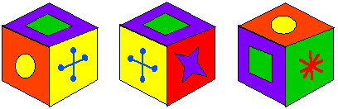
Can you deduce where the faces are in relation to each other and record them on this net of a cube?
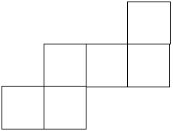

Hint: Print out or draw the faces of the cube. Cut out each one separately and move them around until they fit the views of the cube given.

